Department of Computer Science and Engineering (Data Science)
CSDS-A | Batch A4 (CSE - Data Science, Section A)
Advanced Optimization in E-Commerce Logistics: Combining Matheuristics With Random Forests for Hub Location Efficiency
(HubOptima)
S.No. | Student name | Roll / hall ticket no.
1 | CH.ARCHANA | 23K91A6745
2 | A.MEENAKSHI | 23K91A6705
3 | B.ARUN | 23K91A6734
4 | A.SAMPATH | 23K91A6712
Under the guidance of: [GUIDE NAME], [DESIGNATION]
CONCLUSION, FUTURE SCOPE AND REFERENCES
This document concludes the project: what was achieved, the key findings, the known limitations, concrete future work, and the numbered list of references.

1 Summary of the Work
This project implemented the predict-then-optimise framework of the base paper end to end. A Random Forest forecasts regional demand from lag, rolling, calendar and region features; the forecast feeds a capacitated single-allocation hub-location model; a matheuristic that combines greedy construction, a screened and MIP-priced local search and a kernel search solves it; the plan is scored on the demand that actually occurred; and the cycle is repeated month by month. A FastAPI service and a React application make the pipeline usable from a browser, and a command line and 22 captured screens document it.
The work was carried out on a synthetic dataset of 90 regions and 36 months, because no real order history was available. Every number reported is read from the project's own saved models and results, and the report states where the evidence is weaker than the base paper's.

2 Objectives Achieved
Table 1: Objectives achieved
Objective | Outcome
1 Data collection and preprocessing | Synthetic dataset with cleaning, de-duplication and gap filling (real data not available)
2 Random Forest demand prediction | MAPE 7.67%, R-squared 0.9766; naive forecasters 17.6-19.7% MAPE
3 Optimisation model | Capacitated MIP with cost, delivery-time and capacity constraints and an optional hard SLA
4 Matheuristic | Same plan as the exact MIP at 90 nodes; 4-5 times faster at 90-180 nodes; 3.67% above the exact incumbent at 270 nodes
5 Re-optimisation | 98.3% against 83.7% simulated fulfilment for a static plan
6 Comparison | Proposed plan cheapest of six methods on October 2025; others cost 3.6% to 16.1% more

3 Key Findings
1. Forecasting before optimising pays. Planning on the historical average instead of a forecast cost 8.1% more and served 66.0% of the October 2025 orders, against 92.3%.
2. The matheuristic is exact where exactness can be checked. It found the optimum at 90 and 180 nodes. Its advantage is speed at 180 nodes and above; at 90 nodes there was no practical gain.
3. Re-planning protects service in the peak. In October the adaptive plan kept 92.4% fulfilment against 64.9% for the static plan.
4. Forecast error shows up as overload. A 13.2% under-forecast of the peak left three of six hubs above capacity; the optimiser has no safety margin, which is the main weakness found.
5. Simple rules are costly. The largest-markets rule costs 16.1% more than the optimised plan and breaches the 48 h service level for some regions.
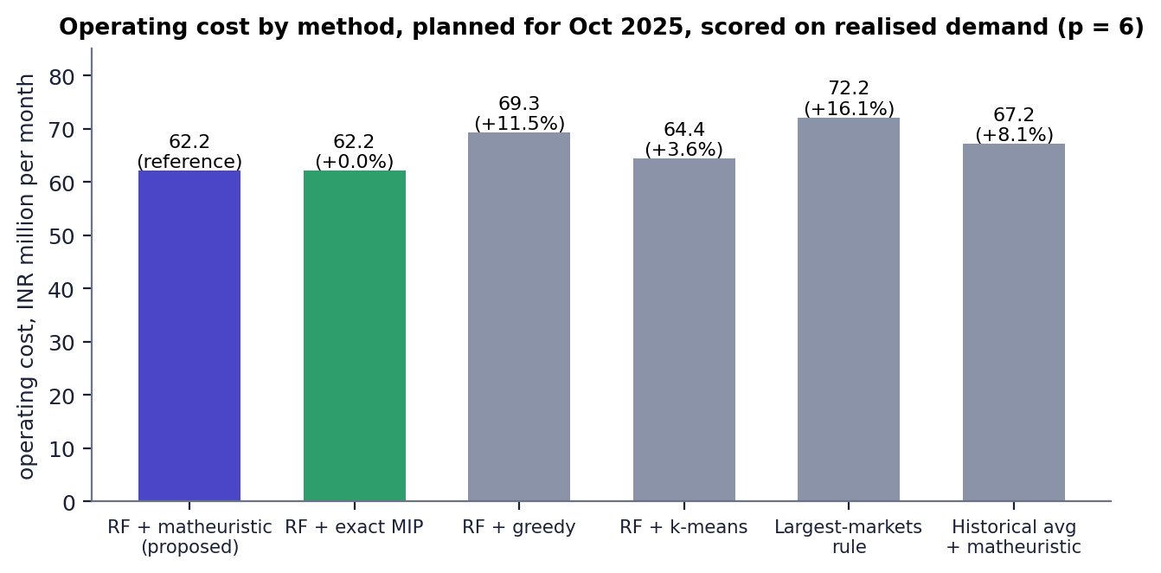
Fig. 1: Operating cost by method (October 2025)

4 Practical Applications
- Monthly review of a regional e-commerce hub network: forecast, plan and see which hubs would be overloaded.
- What-if analysis: change the number of hubs, capacity or service level and see the effect in seconds.
- Teaching: a compact, readable implementation of forecasting plus mixed-integer optimisation plus heuristic search.
- A benchmark harness for comparing a new hub-location heuristic with an exact solver and simple rules.

5 Known Limitations
- Synthetic data; no calibration to a real carrier; fulfilment and reliability are simulated.
- No robustness analysis; the plan is not hedged against forecast error.
- Single capacity level, single allocation, no routing or hub-to-hub economies of scale.
- One hold-out split, no cross-validation or tuning; the model is not retrained monthly in the simulation.
- At 270 nodes the matheuristic is 3.67% above the exact incumbent; networks beyond 270 nodes were not tested.
- No authentication, database or multi-user support; no user acceptance study; no frontend unit tests.

6 Future Scope
The items below follow from the limitations and from the base paper's own future work.

7 Improvements
- Robust plans. Add a safety margin or a scenario-based objective so that a forecast error of 10-15% does not overload the biggest hubs (the base paper's robust direction and [5]).
- Real data. Replace the synthetic files with a real order history (same schema) and re-run the pipeline; calibrate cost parameters with a carrier.
- Forecast quality. Cross-validated tuning, gradient boosting or LSTM benchmarks, prediction intervals, and a fix for the inability of forests to extrapolate beyond past peaks (for example by forecasting growth ratios).
- Solver. Add Variable Neighbourhood Search as in the base paper, tune the kernel size and time rules, and test on 500 nodes.
- Retraining. Retrain the forecaster every month inside the rolling horizon and compare with the fixed model.

8 Additional Features
- Multiple capacity levels per hub and capacity expansion over time.
- Split allocation (a region served by two hubs) and hub-to-hub transport with economies of scale.
- Explainability: a per-region forecast explanation and a map of why a hub was chosen (as proposed in the base paper's future work).
- Scenario manager: save, name and compare several plans side by side; export plans to Excel or PDF.
- Sustainability objectives such as emissions per parcel.

9 Scalability and Deployment
- Move results from files to a database with versioning so several users can plan at once.
- Add sign-in, roles and rate limiting; put the API behind a reverse proxy; containerise the stack.
- Run long jobs in a worker queue instead of threads so that jobs survive a restart and can run in parallel.
- Use a faster commercial or open-source solver for networks above a few hundred nodes, and parallelise the sub-problem pricing.
- Stream new orders from the warehouse system so that the forecast is refreshed without manual file replacement.

10 Further Research
- Compare the matheuristic with VNS-based and learning-based solvers on public hub-location benchmarks.
- Learn the matheuristic's parameters (screening tolerance, kernel size) from the instance, as the base paper suggests for the Random Forest.
- Study how forecast accuracy translates into plan quality: a sensitivity analysis of cost and overload against forecast error.
- Integrate demand uncertainty learned from data into a two-stage robust model.
- Evaluate with a logistics partner on real parcel data, including delivery-time compliance measured in the field.

REFERENCES
[1] K. Danach, A. Rammal, I. Moukadem, H. Harb, and A. Nasser, "Advanced optimization in e-commerce logistics: Combining matheuristics with random forests for hub location efficiency," IEEE Access, vol. 13, pp. 55915-55926, 2025, doi: 10.1109/ACCESS.2025.3550560.
[2] L. Zheng, G. Xu, and W. Chen, "Using improved particle swarm optimization algorithm for location problem of drone logistics hub," Computers, Materials & Continua, vol. 78, no. 1, pp. 935-957, 2024, doi: 10.32604/cmc.2023.046006.
[3] L. Yang, J. Zheng, J. Wang, and X. Hu, "The maximal detour liner shipping hub location problem: Improving the applicability of the p-hub center problem," Transportation Research Part E: Logistics and Transportation Review, vol. 179, Art. no. 103330, Nov. 2023, doi: 10.1016/j.tre.2023.103330.
[4] M. Dehghan Chenary, A. Ferdowsi, and R. F. Hartl, "A Pareto-based clustering approach for solving a bi-objective mobile hub location problem with congestion," Logistics, vol. 8, no. 4, Art. no. 130, Dec. 2024, doi: 10.3390/logistics8040130.
[5] H. Zhang, J.-C. Wang, and Y. Gao, "Two-stage adaptive robust hub location problem under demand uncertainty," Naval Research Logistics, Dec. 2025, doi: 10.1002/nav.70043.
[6] M. E. O'Kelly, "The location of interacting hub facilities," Transportation Science, vol. 20, no. 2, pp. 92-106, 1986.
[7] J. F. Campbell, A. T. Ernst, and M. Krishnamoorthy, "Hub location problems," in Facility Location: Applications and Theory. Berlin, Germany: Springer, 2002, pp. 373-407.
[8] A. T. Ernst and M. Krishnamoorthy, "Efficient algorithms for the uncapacitated single allocation p-hub median problem," Location Science, vol. 4, no. 3, pp. 139-154, Oct. 1996.
[9] K. Danach, S. Gelareh, and R. Neamatian Monemi, "The capacitated single-allocation p-hub location routing problem: A Lagrangian relaxation and a hyper-heuristic approach," EURO Journal on Transportation and Logistics, vol. 8, no. 5, pp. 597-631, Dec. 2019.
[10] M. Kahalimoghadam, R. G. Thompson, and A. Rajabifard, "Determining the number and location of micro-consolidation centres as a solution to growing e-commerce demand," Journal of Transport Geography, vol. 117, Art. no. 103875, May 2024.
[11] L. Breiman, "Random forests," Machine Learning, vol. 45, no. 1, pp. 5-32, Oct. 2001.
[12] V. Maniezzo, M. A. Boschetti, and T. Stuetzle, Matheuristics: Algorithms and Implementations. Cham, Switzerland: Springer, 2021.
[13] F. Pedregosa et al., "Scikit-learn: Machine learning in Python," Journal of Machine Learning Research, vol. 12, pp. 2825-2830, 2011.
[14] S. Mitchell, M. O'Sullivan, and I. Dunning, "PuLP: A linear programming toolkit for Python," Dept. of Engineering Science, University of Auckland, 2011.
[15] J. Forrest and R. Lougee-Heimer, "CBC user guide," in Emerging Theory, Methods, and Applications, INFORMS TutORials in Operations Research, 2005, pp. 257-277.
[16] P. Hansen and N. Mladenovic, "Variable neighborhood search: Principles and applications," European Journal of Operational Research, vol. 130, no. 3, pp. 449-467, May 2001.
[17] E. Angelelli, R. Mansini, and M. G. Speranza, "Kernel search: A general heuristic for the multi-dimensional knapsack problem," Computers & Operations Research, vol. 37, no. 11, pp. 2017-2026, Nov. 2010.
[18] S. P. Lloyd, "Least squares quantization in PCM," IEEE Transactions on Information Theory, vol. 28, no. 2, pp. 129-137, Mar. 1982.
[19] R. J. Hyndman and G. Athanasopoulos, Forecasting: Principles and Practice, 3rd ed. Melbourne, Australia: OTexts, 2021.
[20] R. W. Sinnott, "Virtues of the haversine," Sky and Telescope, vol. 68, no. 2, p. 159, 1984.
[21] S. Ramirez, "FastAPI documentation." [Online]. Available: https://fastapi.tiangolo.com
[22] Meta Platforms, "React documentation." [Online]. Available: https://react.dev

